**Smart Blind Stick**

Project Report

Course Code - EEE-2422

Course Title - Electrical Drives and Instrumentation Lab

**Submitted By**

Group - H

C201216 Kanita Haider

C201222 Rahanuma Zannat

C201224 Sabrina Mostary

C201228 Sanzida Hossain

C201239 Sadia Hasan Chowdhury

Semester - 5AF

**Submitted To**

Md. Belal Uddin Sifat

Adjunct Faculty

Dept. of CSE, IIUC



Department of Computer Science and Engineering

International Islamic University Chittagong

Bangladesh

**Abstract**

Blindness or visual impairment is a word used to describe those who are unable to see. They suffer from a lack of capacity to perform daily tasks such as strolling down the street, visiting friends or relatives, or doing anything else. As a result, the solution to this major problem is to build a stick that will support the user in walking safely without fear of hitting with anyone on the road or other solid objects. We created a Smart blind stick that scans for objects in front of it and responds by vibrating the stick and emitting a warning sound using an ultrasonic sensor. Using Arduino NANO, this system is designed to deliver artificial vision and object detection. A buzzer will provide the user with all input. A buzzer is used in conjunction with a vibrator motor. Another goal of this technology is to create low-cost and efficient obstacle detection assistance for the blind, allowing visually impaired persons to do the same maneuvers as sighted people.

**INDEX**

1. **Introduction**………………………………………………………………………..**01**
2. **Literature Review**……….………………………………………………….**01**
3. **Methodology**…………………………………………………………………….**02**
4. **Block diagram**……………………………………………………………..**02**
5. **Circuit Diagram**………………………………………………………**02**
6. **Flow-chart**…………………………………………………………………**03**
7. **Description**…………………………………………………………………**04**
8. **Mathematical analysis**……………………………………………….**04**
9. **Required instruments**……………………………………………………………..**05**
10. **Images of the Project** …………………………………………………………**06**
11. **Result analysis**……………………………………………………………………...**06**
12. **Future scope**……………………………………………………………………….**.07**
13. **Conclusion**………………………………………………………………………….**07**
14. **References**………………………………………………………………………….**08**
15. **Appendices**…………………………………………………………………………**08**

**Introduction**

One of the most significant problems for a completely or partially blind person is obstacle detection. So, a blind stick is a novel stick intended for visually impaired persons to aid in navigating. Using modern technology, our suggested smart blind stick enables visually impaired persons to travel with ease. The blind stick is made up of five major components: two ultrasonic sensors, an Arduino board, a buzzer, and a vibration motor. This technique begins by employing ultrasonic sensors to identify impediments ahead through ultrasonic vibrations. When an obstruction is detected, the sensor reports that fact to the micro-controller. As a micro-controller, we utilized an Arduino NANO. The micro-controller then estimates sensor-to-obstacle distance. If the obstacle is not within a certain distance, the circuit has no effect. If the barrier is nearby, the micro-controller transmits operational voltage to the buzzer and vibration motor. The buzzer is transmitted in the circuit as a warning signal, with the frequency changing depending on the object's distance. Another advantage is that it helps the blind to identify whether the room is lit or dark. As a result, this system is beneficial for visually impaired persons since it uses a variety of components to identify obstacles.

**Literature Review**

When traveling, the blind typically employ one of two aids: the traditional white cane or a guiding dog. It is common practice for the visually impaired to use a white cane as a means of getting around. The concept of designing and developing an ultrasonic sensor combines sound monition, which helps the visually impaired, with a vibrating alarm, which helps those who have experienced hearing loss. When a visually impaired person is in danger, a sensor may identify objects within a certain range and warn them with a unique sound or vibration. Providing a smart electronic aid for the visually impaired that provides artificial vision and object recognition has been the subject of a brief study and survey in order to gain a better understanding of the many challenges that have arisen in relation to this endeavor. People who are blind and have trouble seeing curbs, potholes, and other impediments while walking down the street are surveyed for this study. Our concept is geared mostly toward the visually impaired population who are unable to navigate their way around an unfamiliar place on foot. In order to assist the blind live more independently, we want to create a system that guides them around their environment. The standard functionality of a Smart Blind Stick includes monitoring the surrounding environment for obstructions and dangers, delivering information to move left or right, and orienting the user during movement.

**Methodology**

The working method behind this visually impaired stick is based on a simple concept. We are using five key components to build this project - an Ultrasonic Sensor HC SR 04, an Arduino Nano board ,a Buzzer, a Vibration motor and a 9V Battery. Using the ultrasonic sensor, the device detects any obstacle that come in the path of the use and send warnings to the user. The proposed method is shown in the diagrams below.

1. **Block Diagram**

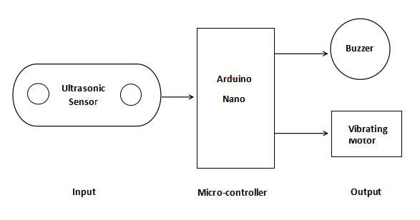

Fig. 1. Block Diagram of the Smart Blind Stick.

1. **Circuit Diagram**

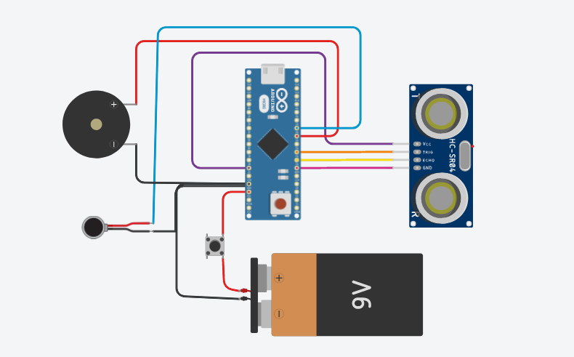

Fig. 2. Circuit Diagram

As shownin Fig.2. From the ultrasonic sensor- Power, Trigger, Echo and Ground Pins are connected respectively to 5v,D3,D2 and GND pin of the Arduino Board.The positive pin of Buzzer is connected to D5 pin of the Arduino and negative side goes to GND. There is also a connection between GND of Arduino and the negative pins of Vibrating Motor and Battery.The other wire of vibrating motor is connected with D6. A Switch connects the Battery to VIN pin of Arduino Nano.

1. **Flow Chart:**

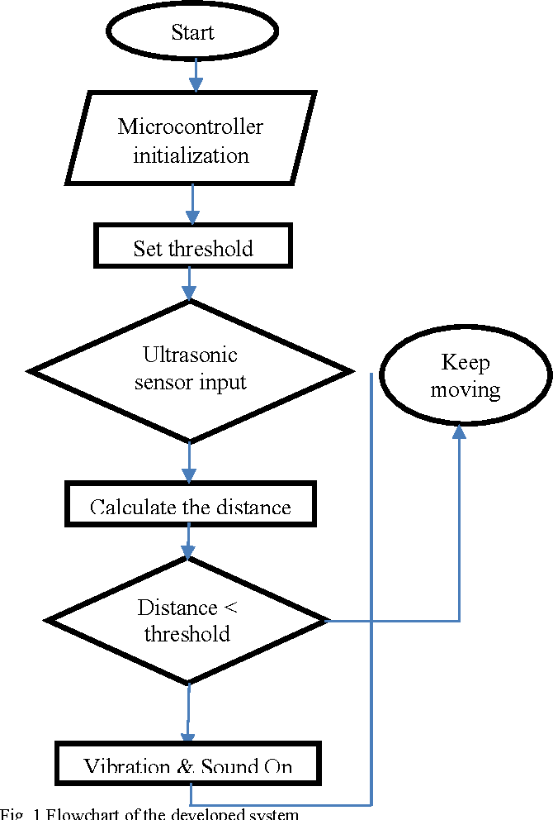

Fig. 3. Flow Chart of the circuit

1. **Description**

In this system, as shown in Fig. 3. The Ultrasonic sensor transmits ultrasonic sound waves from the transmitter portions as soon as the circuit power supply is turned on.When an item passes in front of the sensor, its surface reflects ultrasonic sound waves back to the sensor's receiver portion, which subsequently picks up the wave and produces an output.

The Arduino Nano receives this output data.The device's primary controller is an Arduino board. Using this data, micro-controller calculates the distance between the obstacle and the device. If the distance is within the threshold limit(which is 30cm in our project) then the micro-controller sends signal to Buzzer and Vibrator.The buzzer and vibrating motor are then both given operational voltage by the Arduino. The buzzer now starts to make noise, and the motor begins to vibrate.If not, then device will not give any warning.when an item is not detected by the sensors.Both the buzzer and the motor are disabled in this situation.

1. **Mathematical Analysis**

The "Time of Flight" idea governs how ultrasonic sensors work when using the speed of sound.

Since they have a frequency in the ultrasonic range (>20kHz), the soundscapes created by the ultrasonic sensors are inaudible to human ears. .The sensor emits a range of pulses between 20 KHz and 200 KHz.When sound waves encounter an obstruction, they reflect back to detectors.

Based on the following calculation, we have determine the precise distance we need to measure from the sensor:

Distance = ½( t * c) (t = time and c = the speed of sound)

Distance = ½ ( 0.034*duration)

The speed of sound at 20oC is equal to 343.5 m/s(0.034cm/microsecond), and the time difference between the transmitted signal and the reflected signal is known as (duration).

**Required Instruments**

**A. Hardware**

|  |  |  |
| --- | --- | --- |
| **Picture** | **Product** | **Quantity** |
|  | Arduino nano | 1 |
|  | Ultrasonic Sensor | 1 |
|  | Buzzer | 1 |
|  | Battery(9V) | 1 |
|  | Battery Clip | 1 |
|  | Switch | 1 |
|  | Vibrating Motor | 1 |
|  | Jumper Wire | Required |
|  | Stick | 1 |
|  | Glue | 1 |
|  | Scotch tape | 1 |

**B. Software**

1) Arduino

2) Tinker cad

3) GitHub

4) WPS

**Image of the Implemented Project**

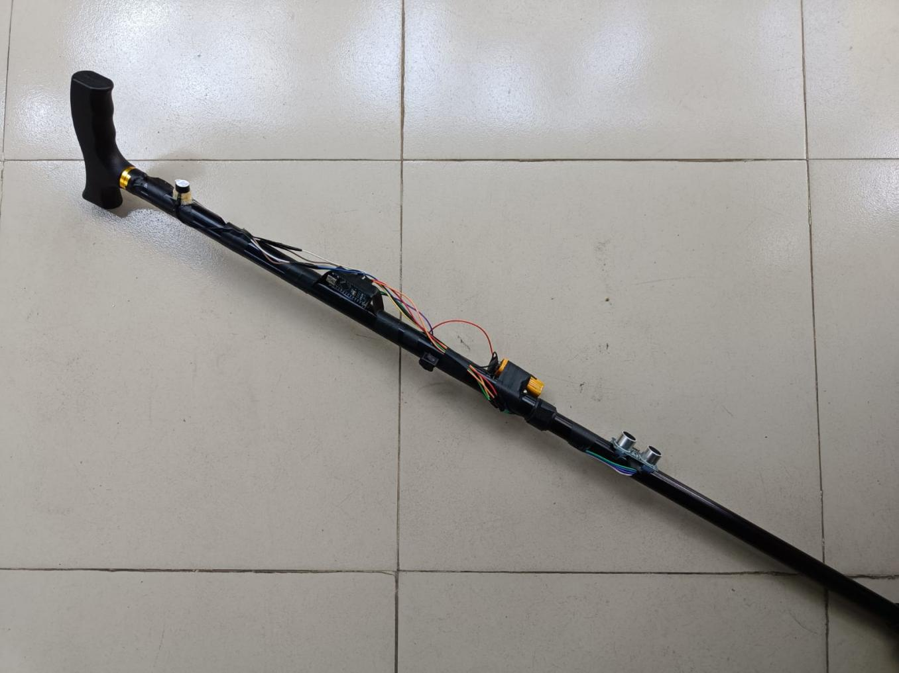

**Result Analysis**

The smart blind stick for blind people that used ultrasonic sensor.The wide range of objects that can be detected by ultrasonic sensors with a big beam angle. Blind people have the ability to detect items up to 30 centimeters distant and can hear feedback via a buzzer. The vibrating motor also vibrates at the same time. Consequently, the blind person can comprehend what is in front of them. It works well to detect objects within a 30 centimeter range. This system provides a reasonable cost, efficient, compact, reduced, and efficient navigation solution with a noticeably quick response time. The Smart Stick is a foundational component of assistive devices that can safely guide the blind through both the indoor and outdoor environments.

**Future scope**

Our smart blind stick has some deficiency in present as it’s now in a trial period. We will work on it in future. Now our blind stick has just 30 cm distance measurement system but in future we will build up this system. As a result, user will warn for repudiates obstacle from long distance. We will add robotic voice system which will inform the user what type of obstacle, it’s height or deep and user’s leisure from the obstacle. We will also add here voice GPS tracking system which will assist user to detect the user’s present location and it will also give direction to the user to reach his/her destination safe and sound.

**Conclusion**

We come to the conclusion that the visually impaired persons can benefit from our project, "Smart Blind Stick." Visual impairment is now present even in young children. They are aware of the risks involved, therefore they cannot take this thing easily. The child or individual will lose the will to walk independently if the risk of injury is rising quickly. The Modern Blind Stick serves as a fundamental foundation to aid those who are blind in securely navigating both indoor and outdoor spaces. Both cost-effective and efficient. People who are blind or visually handicapped now have a much simpler time of it because to this stick. They become more independent and are better able to safely and easily navigate crowded sidewalks. It tries to overcome the problem that blind people on a day to day basis. The smart stick alerts users when there are objects or obstacles in their path. The system's superiority shows that it offers millions of blind people all over the world a low-cost solution.

**References**

* Rathore, A. (2021, September 17). *Project by Dhruvin Patel, Harshit Patel, Hiren Patel & Nirav Patel under the guidance of Prof. Geetali Saha*. Electronics for You. <https://www.electronicsforu.com/electronics-projects/smart-stick-using-arduino-ultrasonic>
* *Smart Stick for Blind Peoples*. (n.d.). Arduino Project Hub. <https://create.arduino.cc/projecthub/mohammadsohail0008/smart-stick-for-blind-peoples-5ee884>
* (2020, April 8). *A Project Based Lab Report On SMART BLIND STICK USING AURDINO SUBMITTED BY*. <https://www.academia.edu/42661755/A_Project_Based_Lab_Report_On_SMART_BLIND_STICK_USING_AURDINO_SUBMITTED_BY>
* (2022, June 15). *SMART BLIND STICK USING ARDUINO ,GSM MODULE ,GSM MODULE,ULTRASONIC SENSOR AND RAIN SENSOR.* Electronics Workshop. <https://electronicsworkshops.com/2020/06/14/smart-blind-stick-using-gsm-module-gsm-moduleultrasonic-sensor-and-rain-sensor/>
* ]*Just a moment. . .* (n.d.-b). <https://www.researchgate.net/publication/356782700_IoT-Based_Smart_Blind_Stick>
* Dey, N., Paul, A., Ghosh, P., Mukherjee, C., De, R., & Dey, S. (2018). Ultrasonic Sensor Based Smart Blind Stick. *2018 International Conference on Current Trends Towards Converging Technologies (ICCTCT)*. <https://doi.org/10.1109/icctct.2018.8551067>
* Dubey, A. (2019). Smart Blind Stick. *International Journal for Research in Applied Science and Engineering Technology*, *7*(5), 815–819. https://doi.org/10.22214/ijraset.2019.5138
* Fakhr, M. A., & Seddik, A. F. (2015). Assistive infrared sensor based smart stick for blind people. *2015 Science and Information Conference (SAI)*. <https://doi.org/10.1109/sai.2015.7237289>
* Grover, S., Hassan, A., Yashaswi, K., & Shinde, N. K. (2020). Smart Blind Stick. *International Journal of Electronics and Communication Engineering*, *7*(5), 19–23. <https://doi.org/10.14445/23488549/ijece-v7i5p104>
* Haider, K. (n.d.). *GitHub - Kanita-Haider/Smart-Blind-Stick: Smart Blind Stick Using Arduino*. GitHub. <https://github.com/Kanita-Haider/Smart-Blind-Stick>
* <https://www.researchgate.net/publication/343186221_Smart_Stick_For_the_Blind_Using_Arduino>

**Appendices**

* GitHub Repository: <https://github.com/Kanita-Haider/Smart-Blind-Stick>
* Circuit Diagram:<https://www.tinkercad.com/things/j9AF7FUZNwZ-blind-stick-circuit>
* Project Video: <https://drive.google.com/file/d/1TMMAnLTu7pdMew4RJwiI-FonJoN4GLIq/view?usp=drivesdk>